**NAME: P. CHANDANA**

**REGISTRATION NUMBER: 192210505**

**S.NO: 25**

**COURSE NAME: FUNDAMENTALS OF**

**COMPUTING ON DATA ANALYSIS**

**COURSE CODE: CSA5779**

**SLOT NAME: D**

**EXPERIMENT:1**

**EXPERIMENT NAME: GENERATION OF NUMBER SERIES**

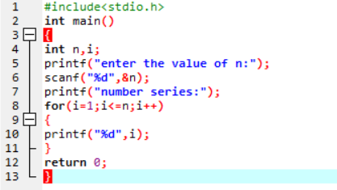**PROGRAM:**

**OUTPUT:**

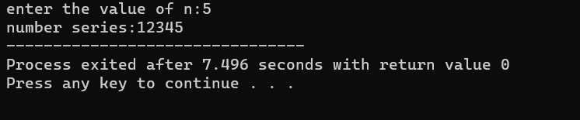

**EXPERIMENT :2**

**EXPERIMENT NAME: GENERATION OF EVEN NUMBER SERIES**

**PROGRAM:**

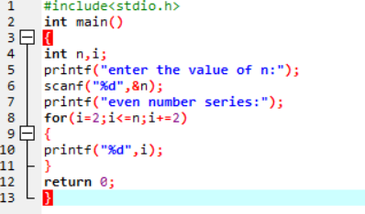

**OUTPUT:**

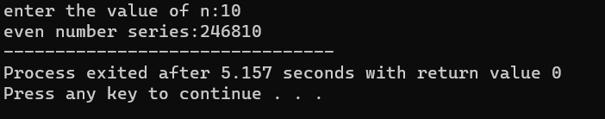

**EXPERIMENT:3**

**EXPERIMENT NAME: GENERATION OF ODD NUMBER SERIES**

**PROGRAM:**

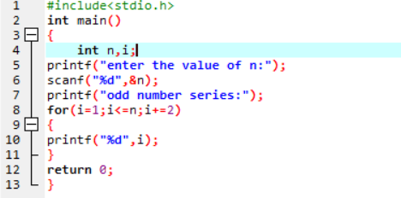

**OUTPUT:**

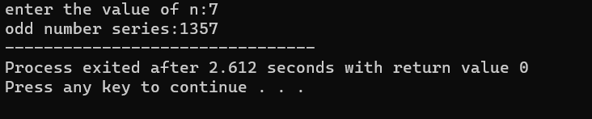

**EXPERIMENT:4**

**EXPERIMENT NAME: GENERATION OF FIBONACCI SERIES**

**PROGRAM:**

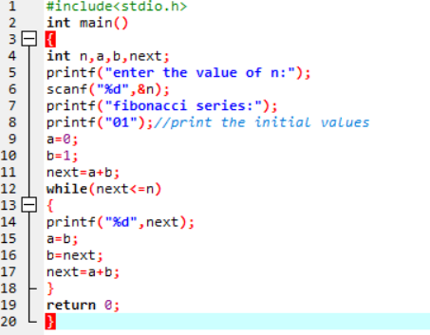

**OUTPUT:**

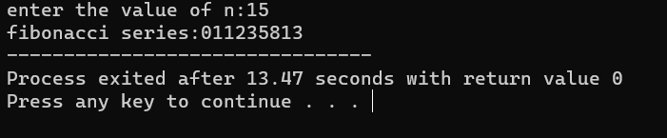

**EXPERIMENT:5**

**EXPERIMENT NAME: SUMMING UP SERIES**

**PROGRAM:**

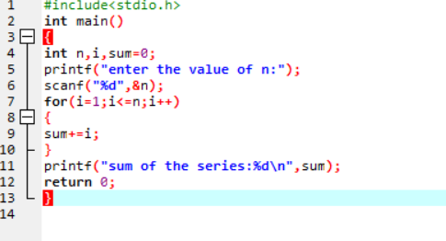

**OUTPUT:**

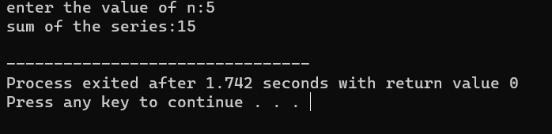

**EXPERIMENT:6**

**EXPERIMENT NAME: SUMMING UP EVEN NUMBER SERIES**

**PROGRAM:**

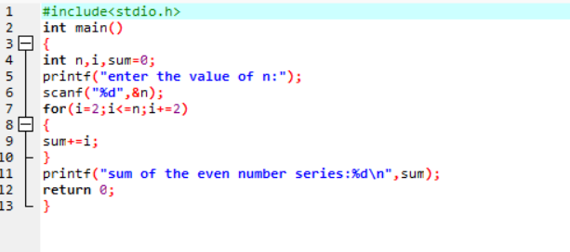

**OUTPUT:**

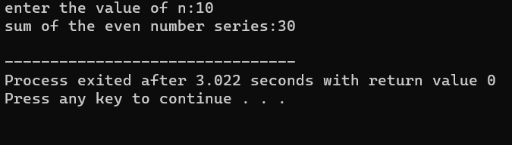

**EXPERIMENT:7**

**EXPERIMENT NAME: SUMMING UP ODD NUMBER SERIES**

**PROGRAM:**

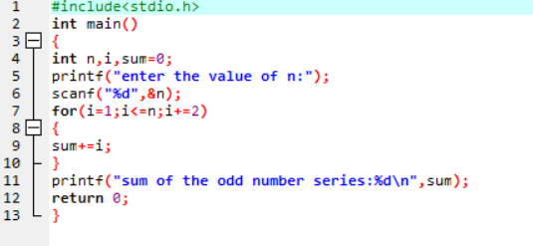

**OUTPUT:**

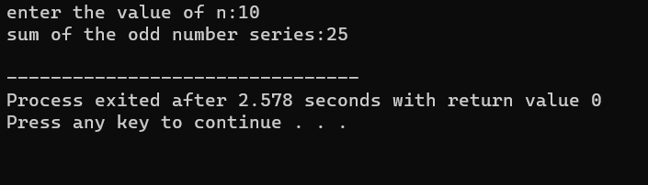

**EXPERIMENT:8**

**EXPERIMENT NAME: SUMMING UP 1-2+3-4+5-------N**

**PROGRAM:**

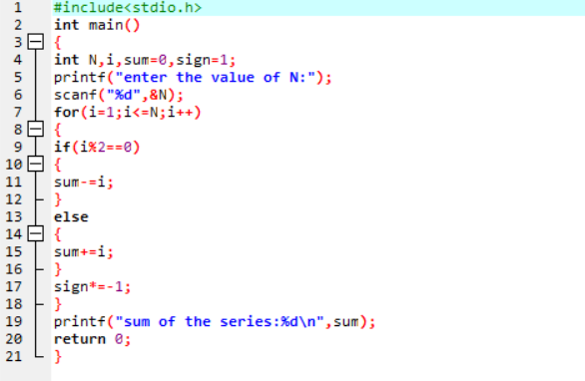

**OUTPUT:**

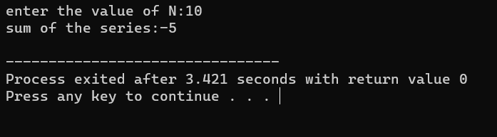

**EXPERIMENT:9**

**EXPERIMENT NAME: SUMMING UP 1^2+2^2+3^2+4^2+--------+n**

**PROGRAM:**

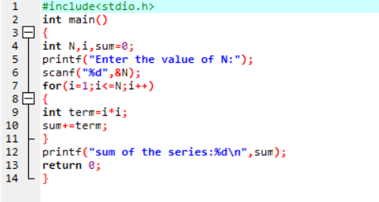

**OUTPUT:**

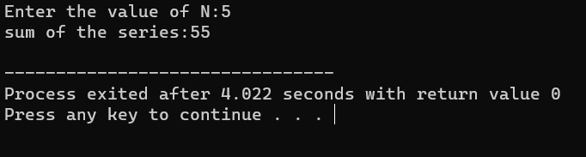

**EXPERIMENT:10**

**EXPERIMENT NAME: SUMMING UP 2^2+4^2+6^2+8^2+-----+n^2**

**PROGRAM:**

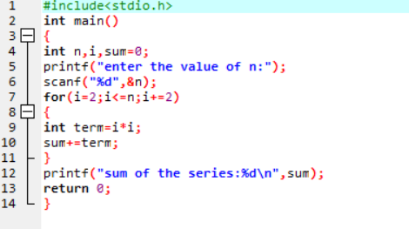

**OUTPUT:**

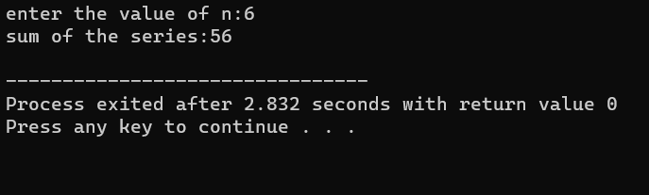

**EXPERIMENT:11**

**EXPERIMENT NAME: SUMMING UP 1^1+2^2+3^3+4^4+-----n^n**

**PROGRAM:**

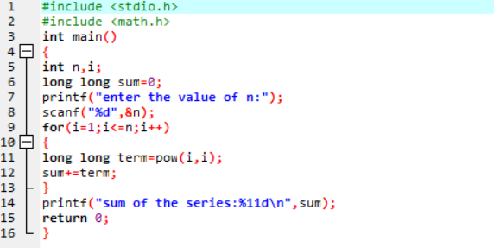

**OUTPUT:**

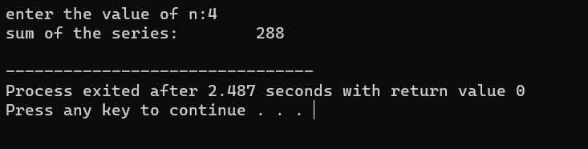

**EXPERIMENT:12**

**EXPERIMENT NAME: SUMMING UP SQUARES OF ODD NUMBERS**

**PROGRAM:**

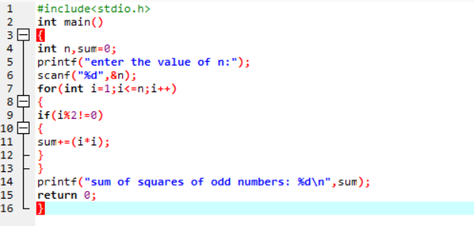

**OUTPUT:**

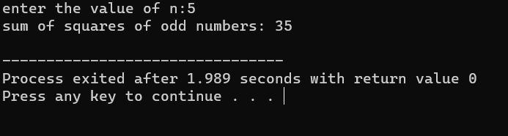

**EXPERIMENT:13**

**EXPERIMENT NAME: SUMMING UP CUBES OF n NUMBERS**

**PROGRAM:**

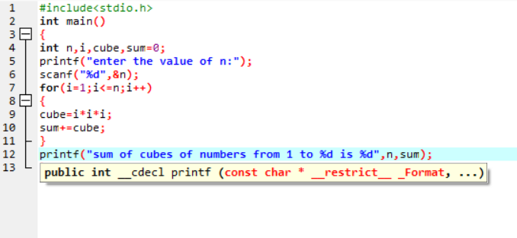

**OUTPUT:**

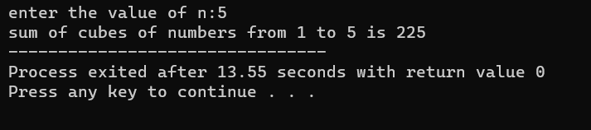

**EXPERIMENT:14**

**EXPERIMENT NAME: PRODUCT SERIES (FACTORIAL OF A GIVEN NUMBER)**

**PROGRAM:**

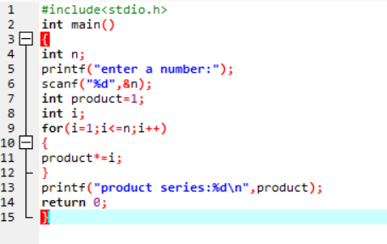

**OUTPUT:**

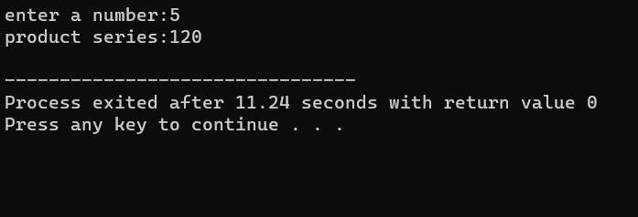

**EXPERIMENT:15**

**EXPERIMENT NAME: FINDING THE GIVEN NUMBER IS ARMSTRONG OR NOT**

**PROGRAM:**

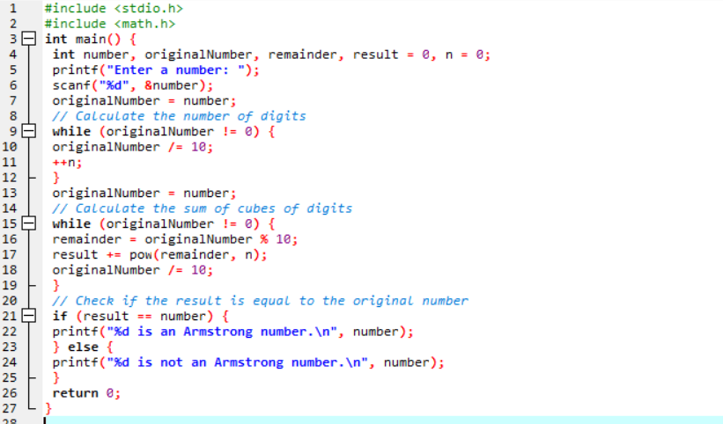

**OUTPUT:**

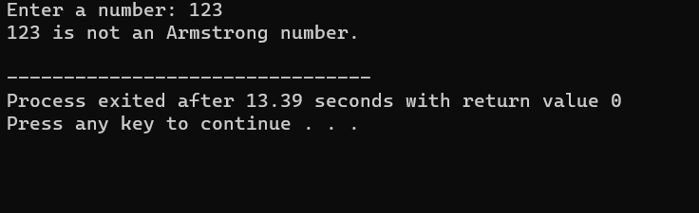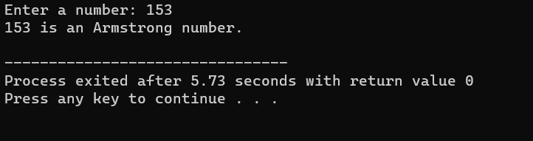

**EXPERIMENT: 16**

**EXPERIMENT NAME: SUMMING UP ANY N NUMBERS AND FINDING AVERAGE**

**PROGRAM:**

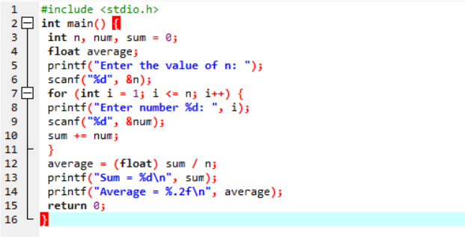

**OUTPUT:**

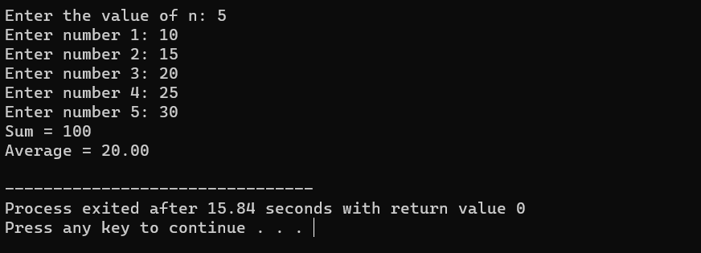

**EXPERIMENT: 17**

**EXPERIMENT NAME: PRINTING DIGITS OF AN INTEGER NUMBER**

**PROGRAM:**

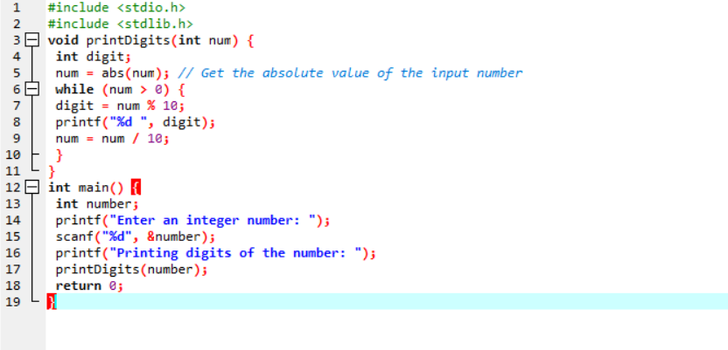

**OUTPUT:**

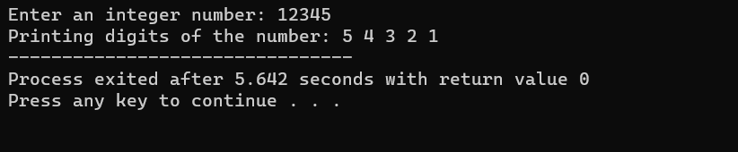

**EXPERIMENT: 18**

**EXPERIMENT NAME: SUMMING UP THE DIGITS OF AN INTEGER NUMBER**

**PROGRAM:**

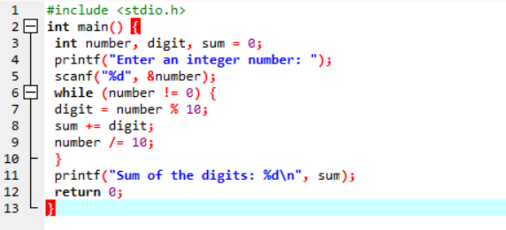

**OUTPUT:**

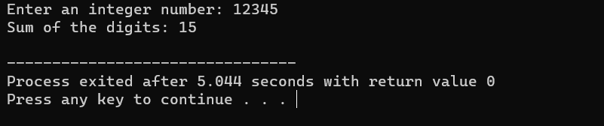

**EXPERIMENT: 19**

**EXPERIMENT NAME: REVERING THE DIGITS OF AN INTEGER NUMBER**

**PROGRAM:**

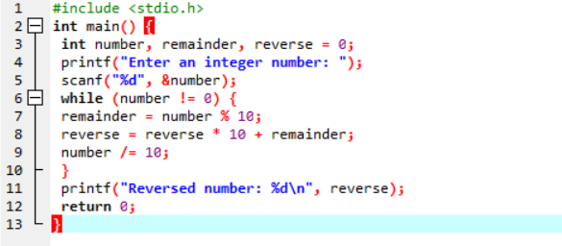

**OUTPUT:**

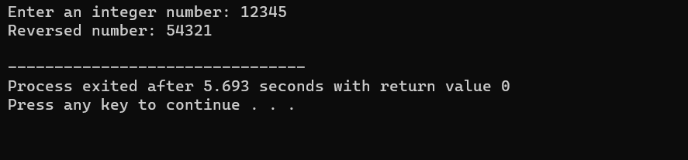

**EXPERIMENT: 20**

**EXPERIMENT NAME: FINDING WHETHER THE GIVEN INTEGER IS ODD OR EVEN**

**PROGRAM:**

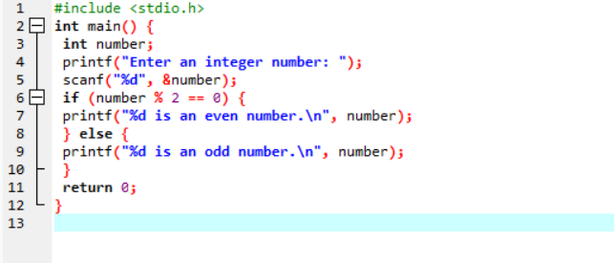

**OUTPUT:**

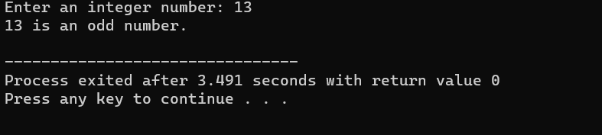

**EXPERIMENT: 21**

**EXPERIMENT NAME: FINDING THE GIVEN INTEGER IS POSITIVE OR NEGATIVE**

**PROGRAM:**

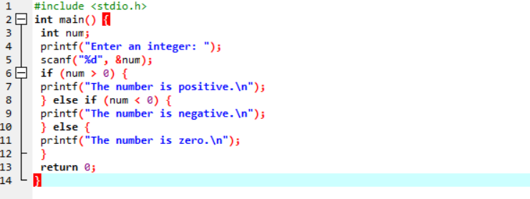

**OUTPUT:**

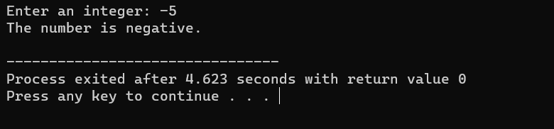

**EXPERIMENT: 22**

**EXPERIMENT NAME: SWAPPING TWO NUMBERS WITH A TEMPORARY VARIABLE**

**PROGRAM:**

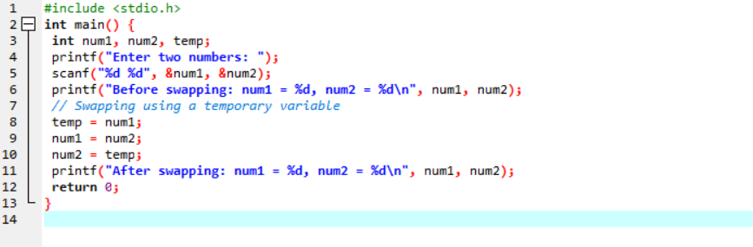

**OUTPUT:**

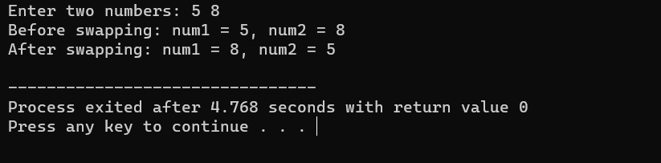

**EXPERIMENT: 23**

**EXPERIMENT NAME: SWAPPING TWO NUMBERS WITHOUT A TEMPORARY VARIABLE**

**PROGRAM:**

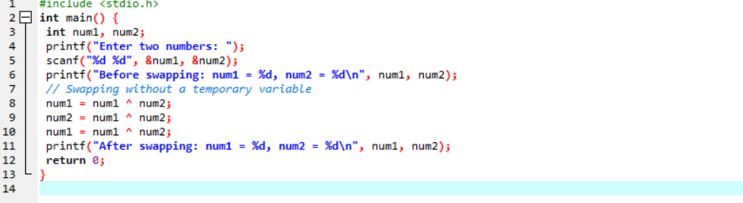

**OUTPUT:**

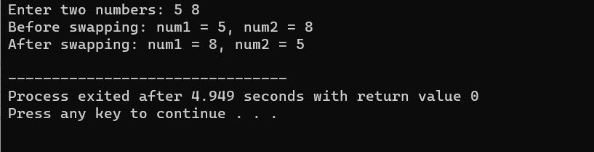

**EXPERIMENT: 24**

**EXPERIMENT NAME: SWAP 3 NUMBERS A TO B, B TO C AND C TO A**

**PROGRAM:**

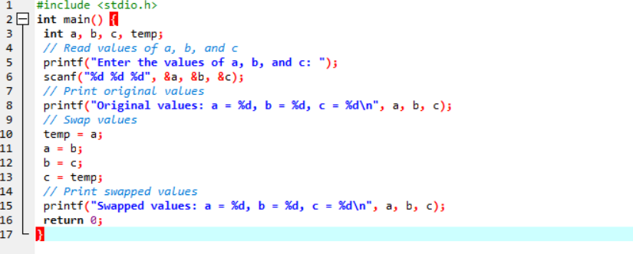

**OUTPUT:**

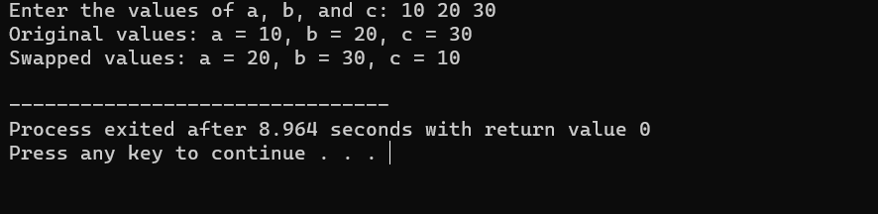

**EXPERIMENT: 25**

**EXPERIMENT NAME: FINDING THE BIGGEST OUT OF 2 INTEGER NUMBERS**

**PROGRAM:**

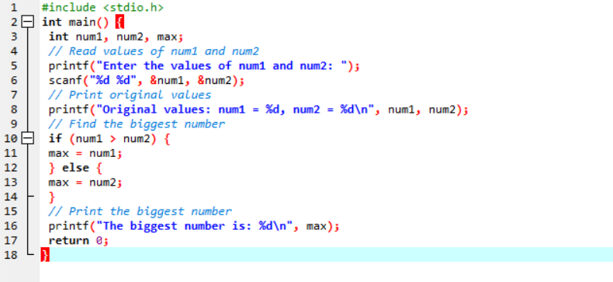

**OUTPUT:**

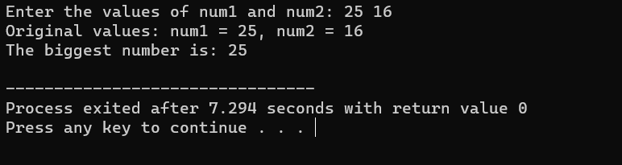

**EXPERIMENT: 26**

**EXPERIMENT NAME: FINDING THE BIGGEST OUT OF N INTEGERS**

**PROGRAM:**

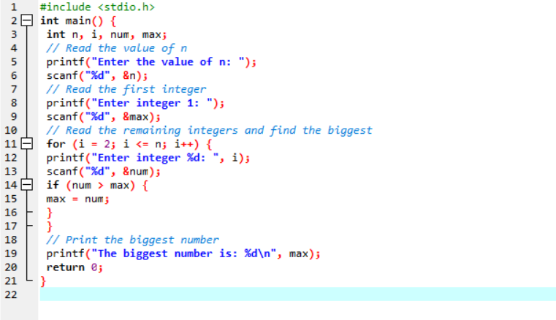

**OUTPUT:**

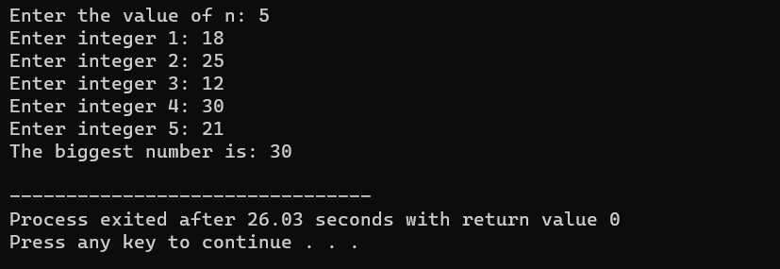

**EXPERIMENT: 27**

**EXPERIMENT NAME: SINE SERIES [SIN(X) =X-X^3/3! + X^5/5! - X^7/7!...........]**

**PROGRAM:**

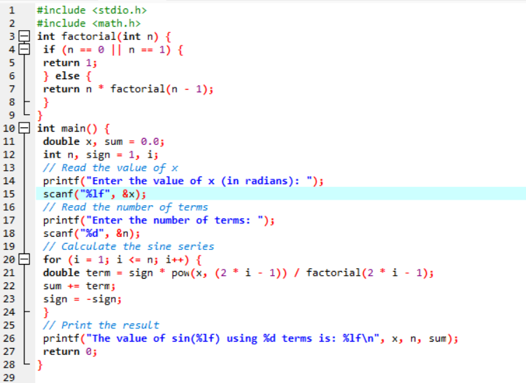

**OUTPUT:**

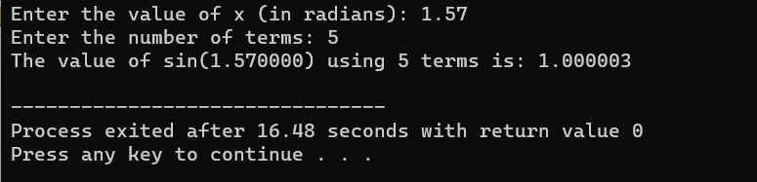

**EXPERIMENT: 28**

**EXPERIMENT NAME: Cos series [cos(x) = 1 – x 2 /2! + x 4 /4! – x 6 /6! . . . . . . ]**

**PROGRAM:**

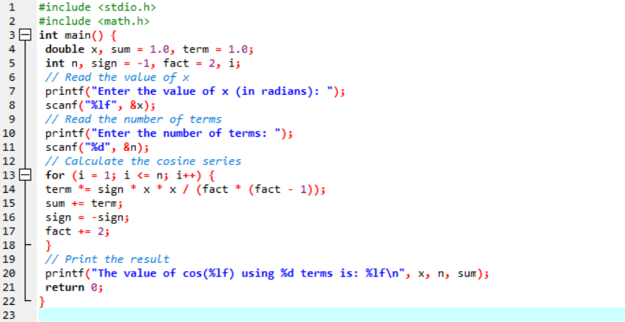

**OUTPUT:**

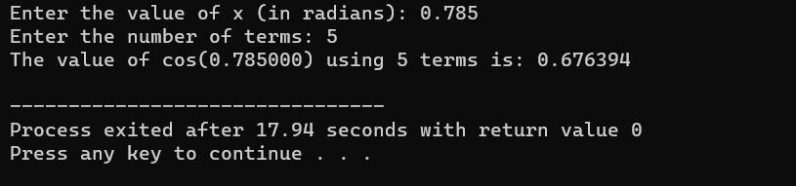

**EXPERIMENT: 29**

**EXPERIMENT NAME:** **Exponential series [e -1 = 1 – x/1! + x 2 /2! – x 3 /3! + x4 /4! . . . . . . ]**

**PROGRAM:**

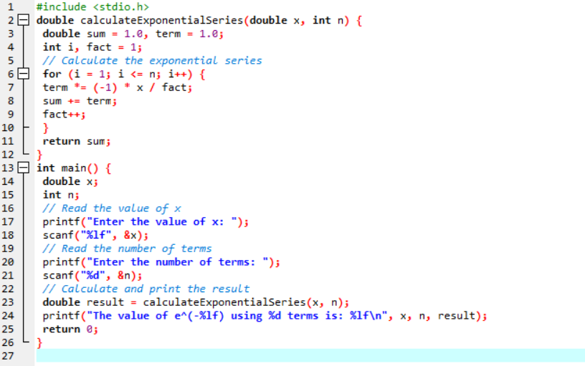

**OUTPUT:**

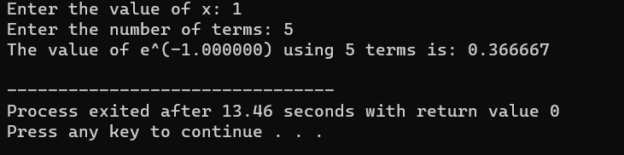

**EXPERIMENT: 30**

**EXPERIMENT NAME: LINEAR SEARCH**

**PROGRAM:**

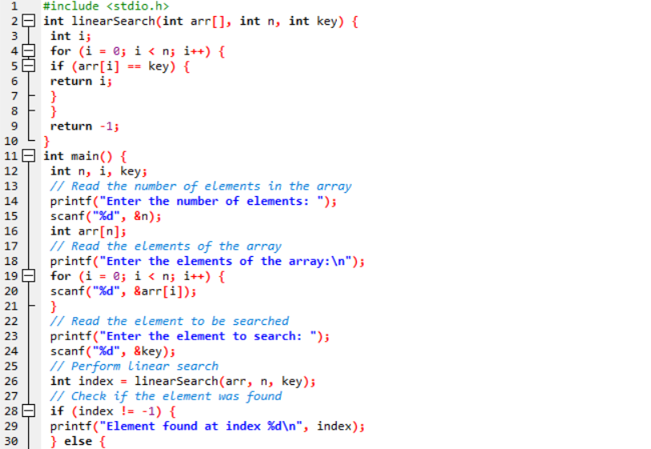

**OUTPUT:**

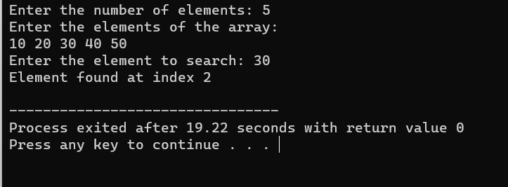

**EXPERIMENT: 31**

**EXPERIMENT NAME: Calculate the water bill given the cubic feet of water used for Eureka Water Company, which charges the homeowner one of the following: a. A flat rate of $15.00 for usage up to and including 1000 cubic feet. b. $0.0175 per cubic foot for usage over 1000 cubic feet and up to and including 2000 cubic feet. c. $0.02 per cubic foot for usage over 2000 cubic feet and up to and including 3000 cubic feet. d. A flat rate of $70.00 for usage over 3000 cubic feet. Write the algorithm, draw the flowchart and write pseudocode to test the above problem.**

**PROGRAM:**

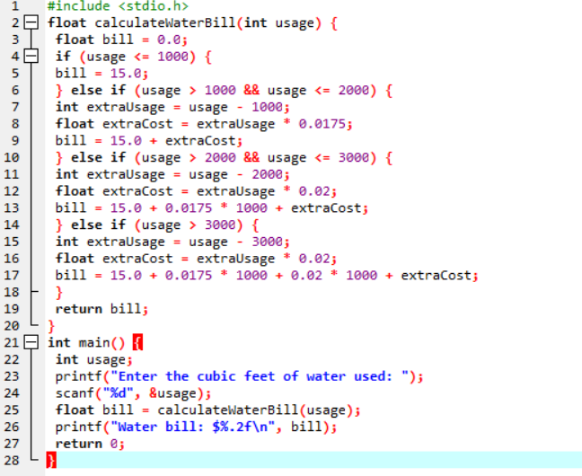

**OUTPUT:**

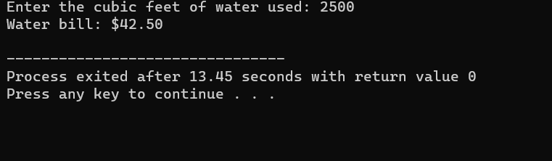

**EXPERIMENT: 32**

**EXPERIMENT NAME: A company that issues check-cashing cards uses an algorithm to create card numbers. The algorithm adds the digits of a four-digit number, and then adds a fifth digit of 0 or 1 to make the sum of the digits even. The last digit in the number is called the check digit. Complete the seven problem-solving steps to develop a solution that accepts a four-digit number into one variable, adds the check digit, and prints the original number and the new number. Test your algorithm, flowchart and pseudocode with the following data: Original (47371) and 4631 (46310). Hint: You may use any or all of these functions and the principle of concatenation of strings. Integer(X)—Integer function String(X)—Numeric to string Value(A)—String to numeric Note: The Integer(X) gives the whole number value of the real number X. When X is 546.43, the Integer(X) is 546; when X is 23.899 the Integer(X) is 23. The String(X) and Value(A) are conversion functions. The resultant of the function String(X) is the string value of the numeric X. The resultant of Value(A) is the numeric value of the string A. Concatenation is the combining of strings by placing the first string in front of the second one. For example, the resultant of would be “45.”**

**PROGRAM:**

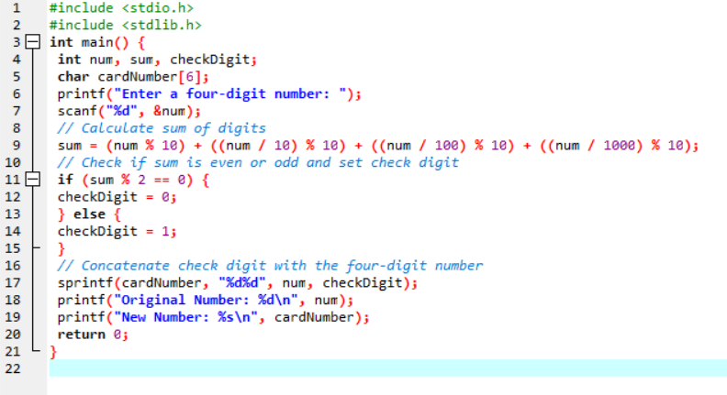

**OUTPUT:**

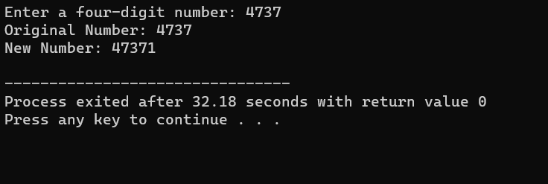

**EXPERIMENT: 33**

**EXPERIMENT NAME**: **An admission charge for The Little Rep Theatre varies according to the age of the person. Develop a solution to print the ticket charge given the age of the person. The charges are as follows: a. Over 55: $10.00 b. 21–54: $15.00 c. 13–20: $10.00 d. 3–12: $5.00 e. Under 3: Free**

**PROGRAM:**

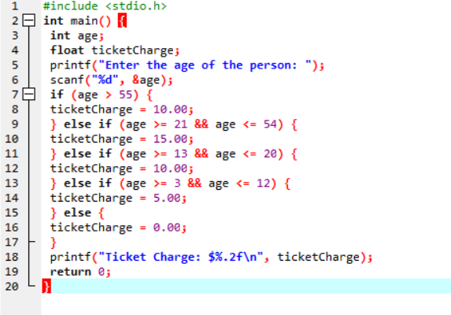

**OUTPUT:**

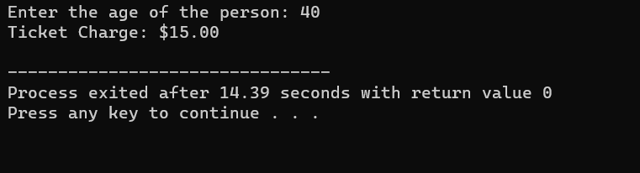

**EXPERIMENT: 34**

**EXPERIMENT NAME: A hotel has a pricing policy as follows: a. 2 people: $85 b. 3 people: $90 c. 4 people: $95 d. Additional people: $6 per person If the customer is staying on company business, there is a 20% discount. If the customer is over 60 years of age, there is a 15% discount. A customer does not receive both discounts. Given the above data, print the cost of the room.**

**PROGRAM:**

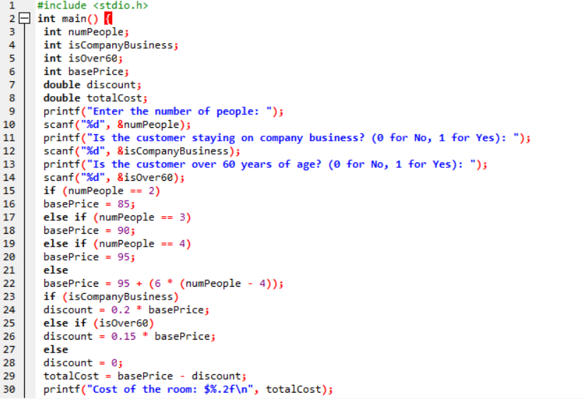

**OUTPUT:**

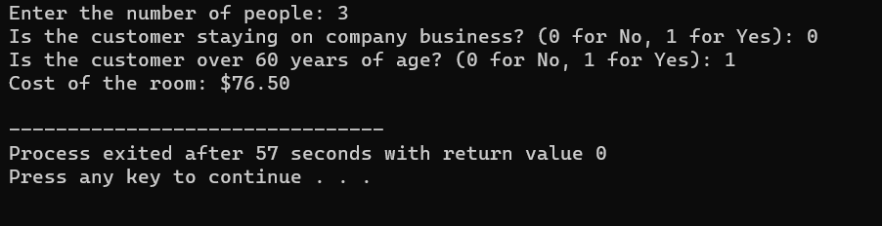

**EXPERIMENT: 35**

**EXPERIMENT NAME: A student wants to know his grade point average for the semester. The grades are given in letter grades with numeric equivalents. Develop a solution to calculate a grade point average given the letter grades. (Remember, the grade point average is figured per unit of credit, not per course.) An A = 4.0, B = 3.0, C = 2.0, D = 1.0, F = 0.0. Write the algorithm to test the solution with the following data and draw flowchart and write pseudocode: History B 3 units Economics A 3 units PE A 1 unit Chemistry C 4 units Art B 3 units (Hint: Use a trip value to stop the processing of the loop and a case structure to find the grade points.)**

**PROGRAM:**

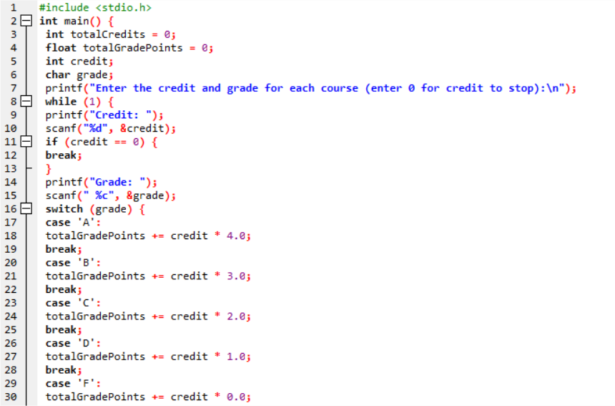

**OUTPUT:**

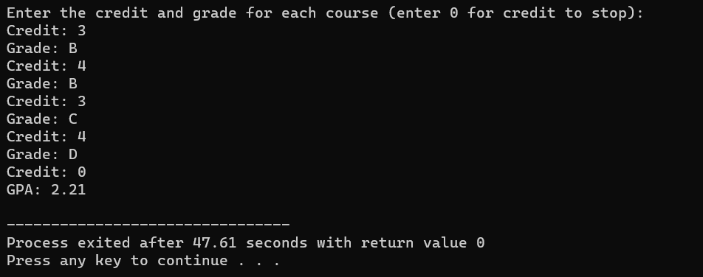

**EXPERIMENT: 36**

**EXPERIMENT NAME: Mr. Johnson would like to know how many As, Bs, Cs, Ds, and Fs his students received on a test. He has 200 students who took the test. He would like to enter the student number and the number grade for the test for each student. Develop the solution to print out each student’s student number, number grade, letter grade, and the total number of As, Bs, Cs, Ds, and Fs. His grading scale is as follows: 90–100 is an A, 78–89 is a B, 65– 77 is a C, 50–64 is a D, and below 50 is an F. Write the algorithm, draw the flowchart and write pseudocode to test the above problem.**

**PROGRAM:**

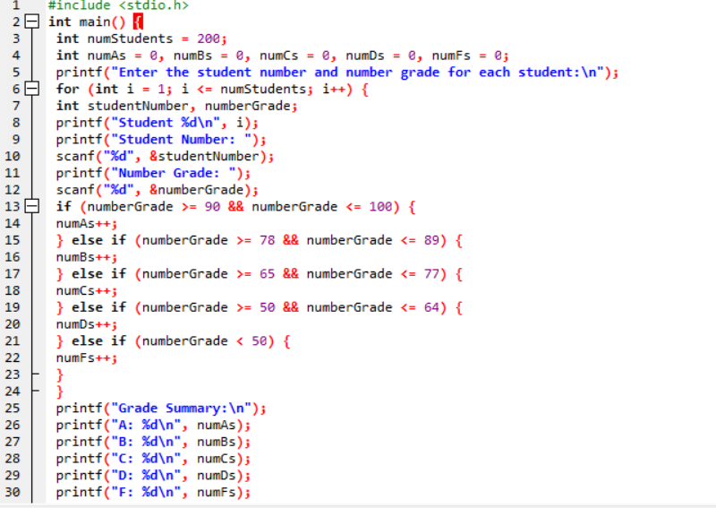

**OUTPUT:**

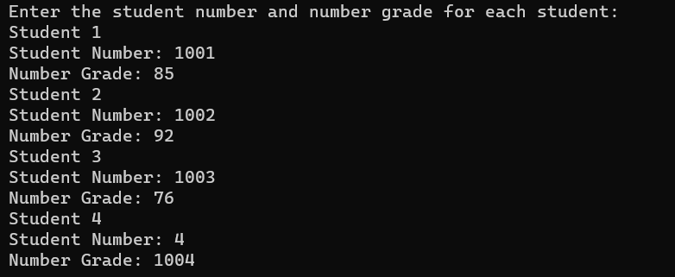

**EXPERIMENT: 37**

**EXPERIMENT NAME: John Smith is a new car salesperson. Write the algorithm and a program to calculate the total cost of a car given the following. initial price of the car 0 to 10 accessories (the computer would select the price according to the accessory) sales ta**

**PROGRAM:**

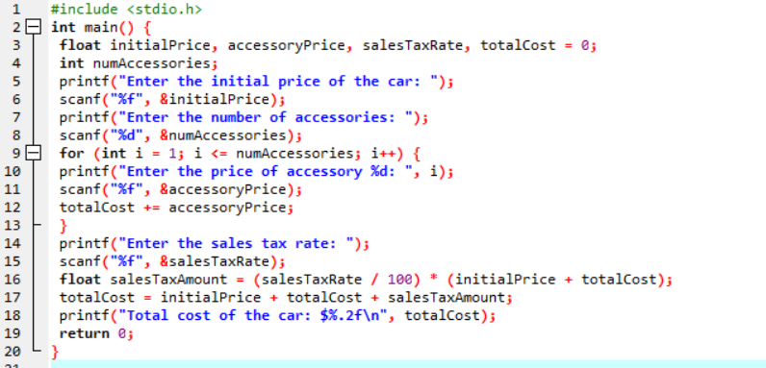

**OUTPUT:**

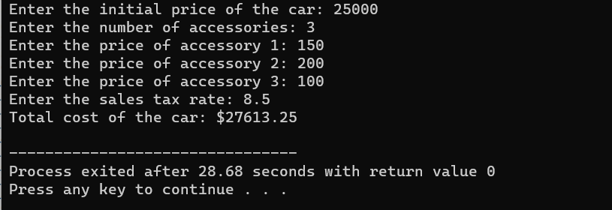

**EXPERIMENT: 38**

**EXPERIMENT NAME: The Last Stop Boutique is having a five-day sale. Each day, starting on Monday, the price will drop 10% of the previous day’s price. For example, if the original price of a product is $20.00, the sale price on Monday would be $18.00 (10% less than the original price). On Tuesday the sale price would be $16.20 (10% less than Monday). On Wednesday the sale price would be $14.58; on Thursday the sale price would be $13.12; and on Friday the sale price would be $11.81. Develop a solution that will calculate the price of an item for each of the five days, given the original price. Write the algorithm, flowchart and pseudocode to test the solution**

**PROGRAM:**

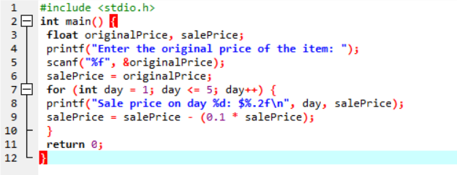

**OUTPUT:**

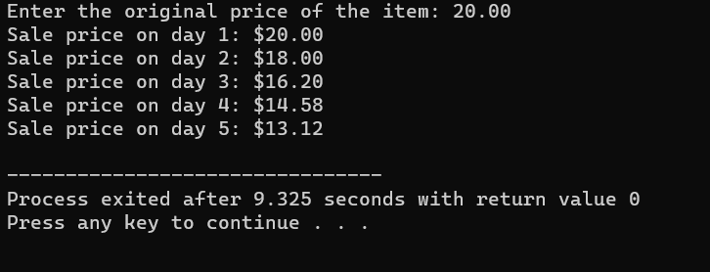

**EXPERIMENT: 39**

**EXPERIMENT NAME: Mary Smith, a student, has borrowed $3,000 to help pay her college expenses. After setting up a budget, $85 was the maximum monthly payment she could afford to make on the loan. Develop a solution to calculate and print the interest, the principal, and the balance on the loan per month. Other information she would like to know is the number of years and months it will take to pay the loan back and the total interest she will pay during that period. The interest rate is 1% per month on the unpaid balance. Write the algorithm, flowchart and pseudocode to test the solution.**

**PROGRAM:**

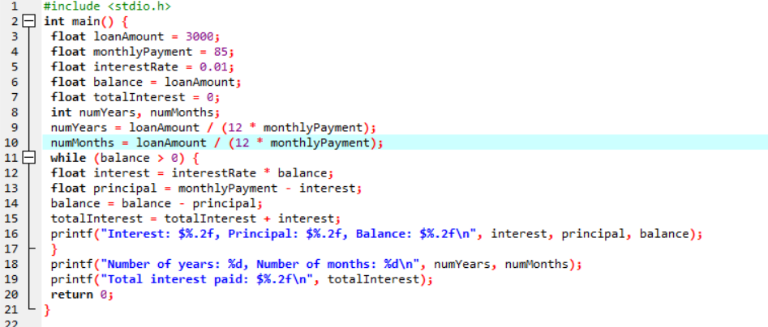

**OUTPUT:**

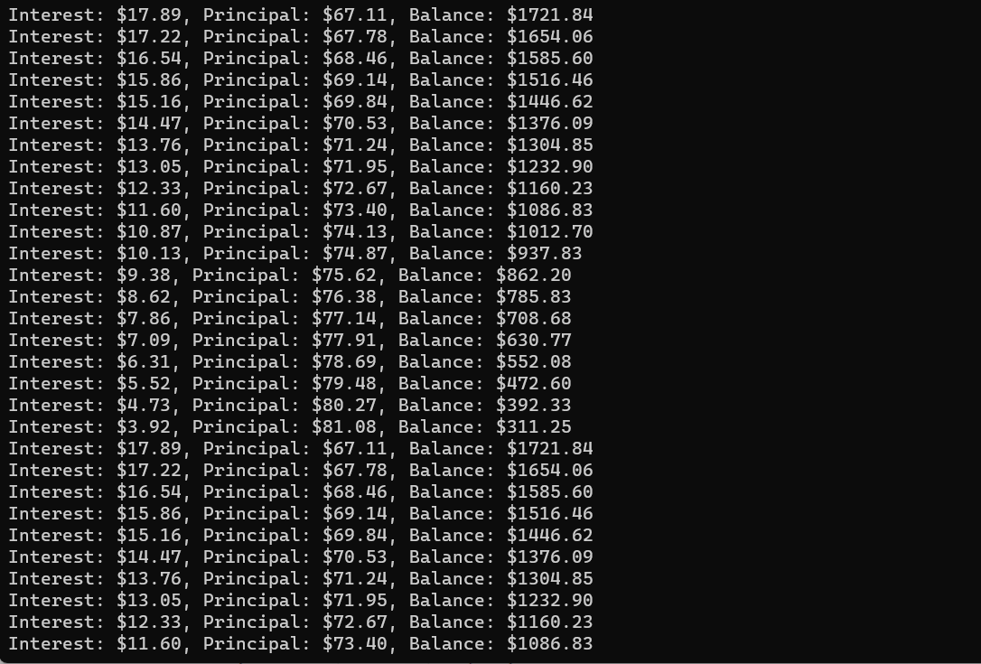

**EXPERIMENT: 40**

**EXPERIMENT NAME: Write a solution (algorithm, flowchart and program) to find the average miles per gallon on a car after six fill ups at a gas station. Additional data kept included the number of gallons of gas at each fill up, the starting odometer reading, and the odometer reading at each fill up.**

**PROGRAM:**

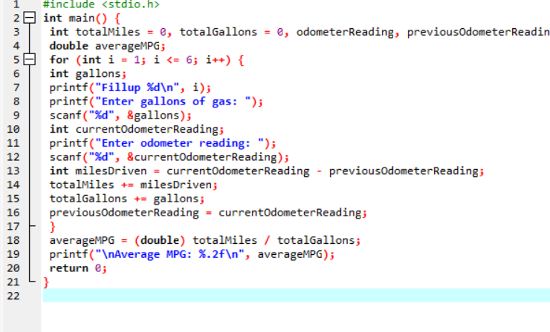

**OUTPUT:**

